ECS-React-Spring-boot

Pre-requisite
Make sure the React and spring boot app is working fine on the docker compose
Services to AWS integrated
Secret Manager
API Gateway

Note: the API gateway and other ENV details are configured inside the APP during the docker image creation
The Docker images are uploaded to the hub.docker.com

Steps:
Step1—Setup ECS Cluster
Step2: Create Frontend task definition
Step3: Create service for Frontend task
Step4: Create Backend task definition
Step5: Create service for Backend task
Step6: API Gateway configuration

Step1—Setup ECS Cluster

Below shows the configurations, that we have an ECS cluster on the Fargate.
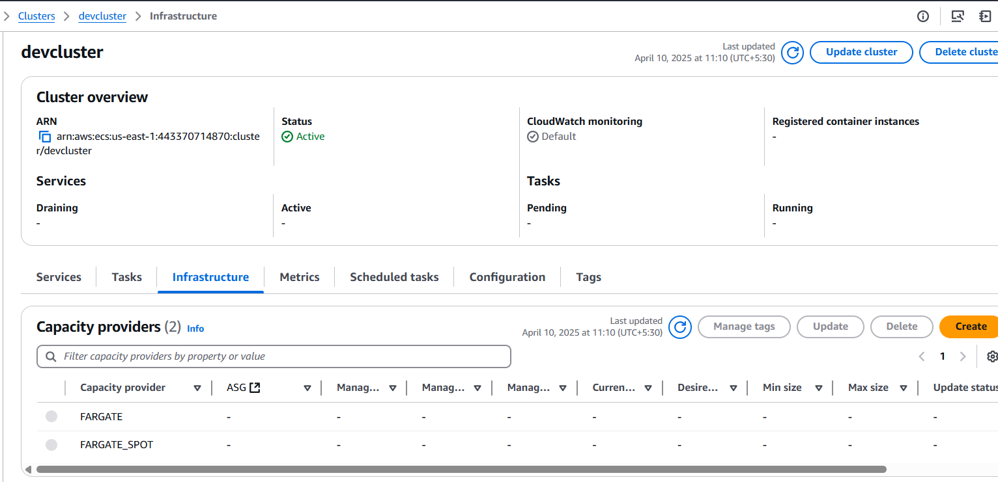
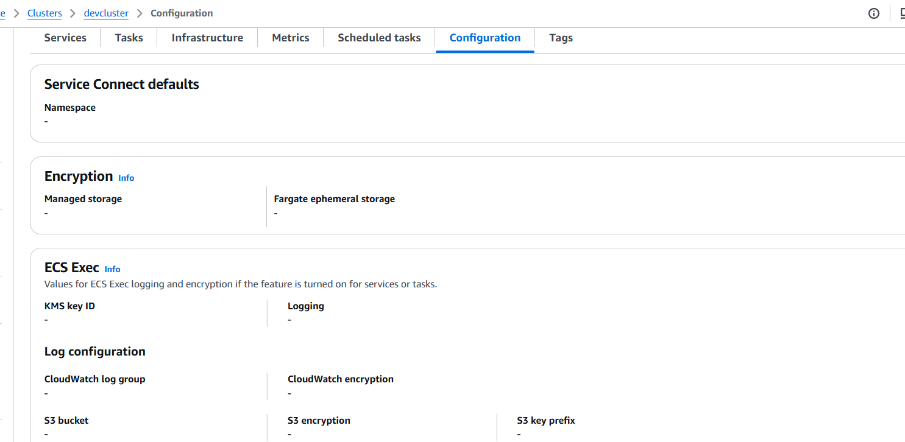

Step2: Create Frontend task definition
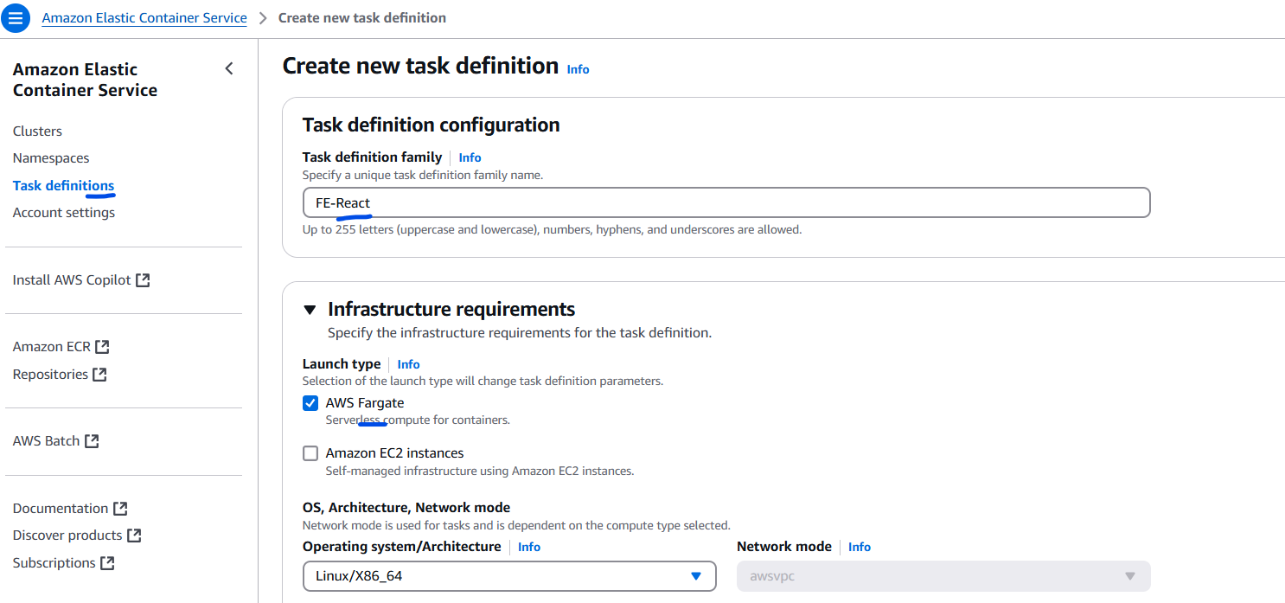
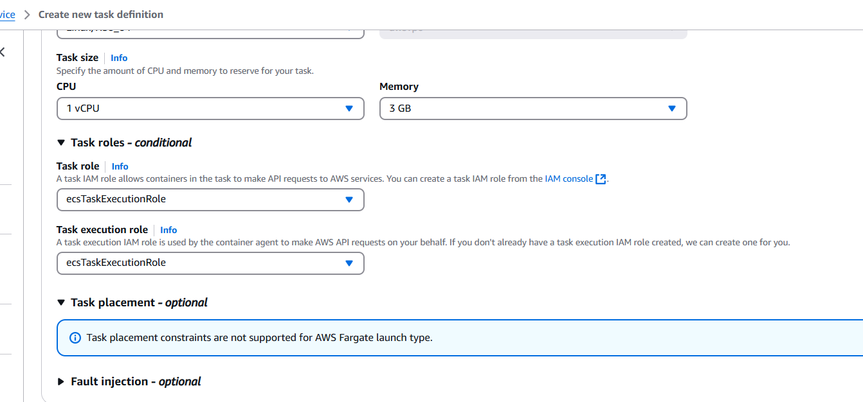
Now lets configure the container for FE.
Note: the ecsTaskExecutionRole is already created.
The Role details
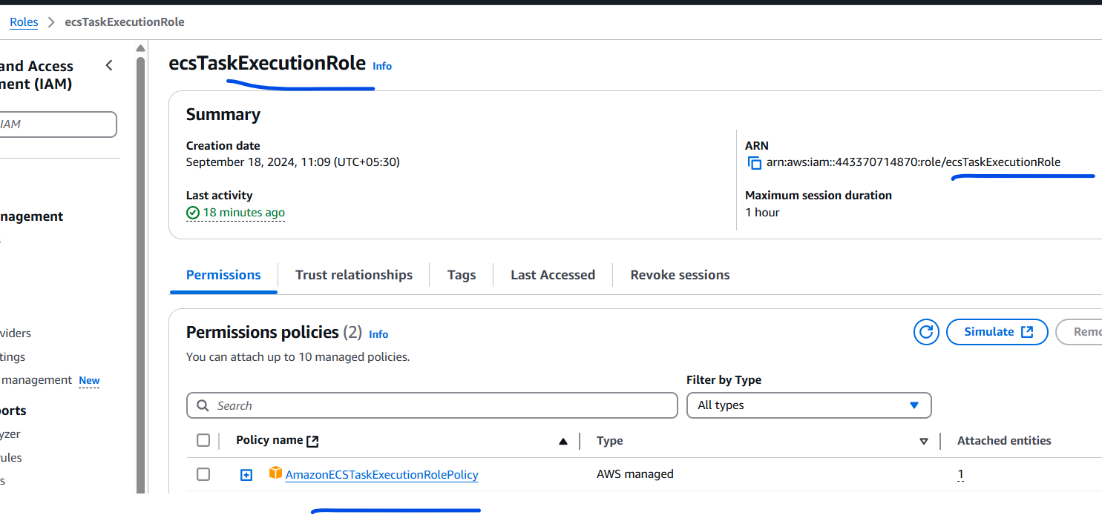
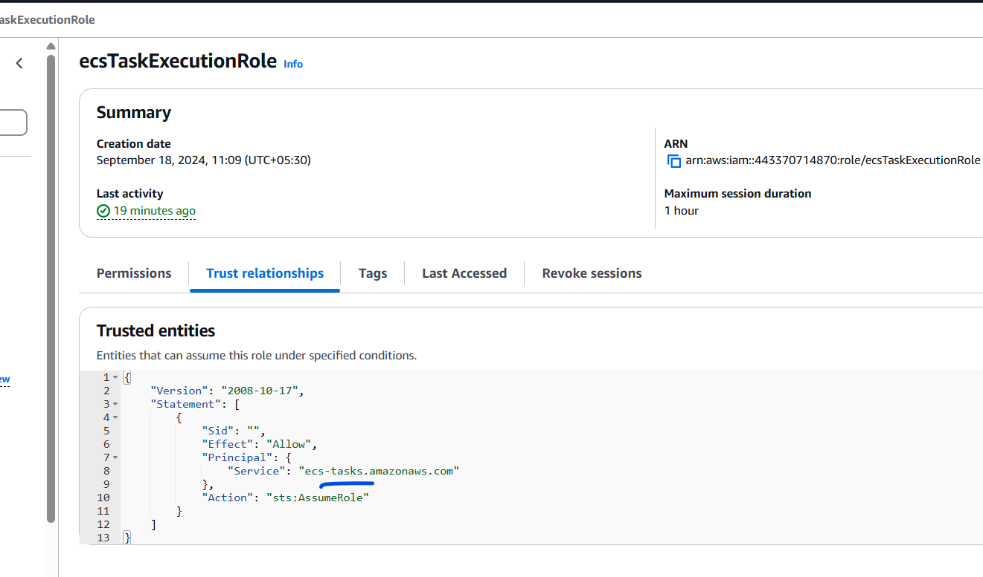
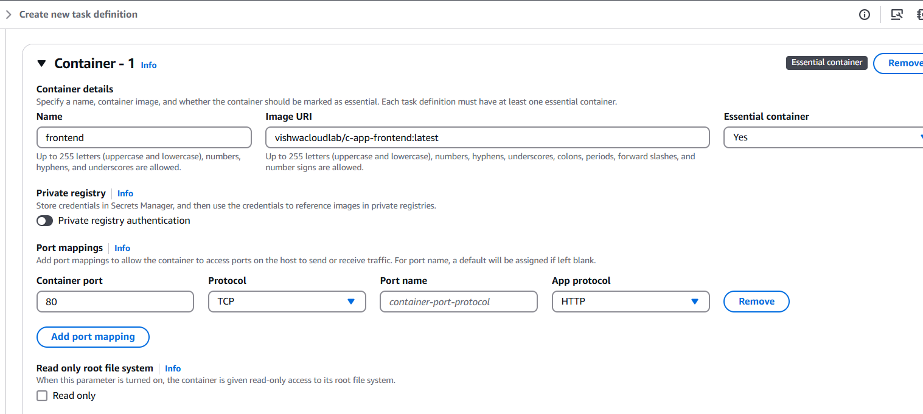
The react is running on nginx, so the port “80” is exposed for the access.
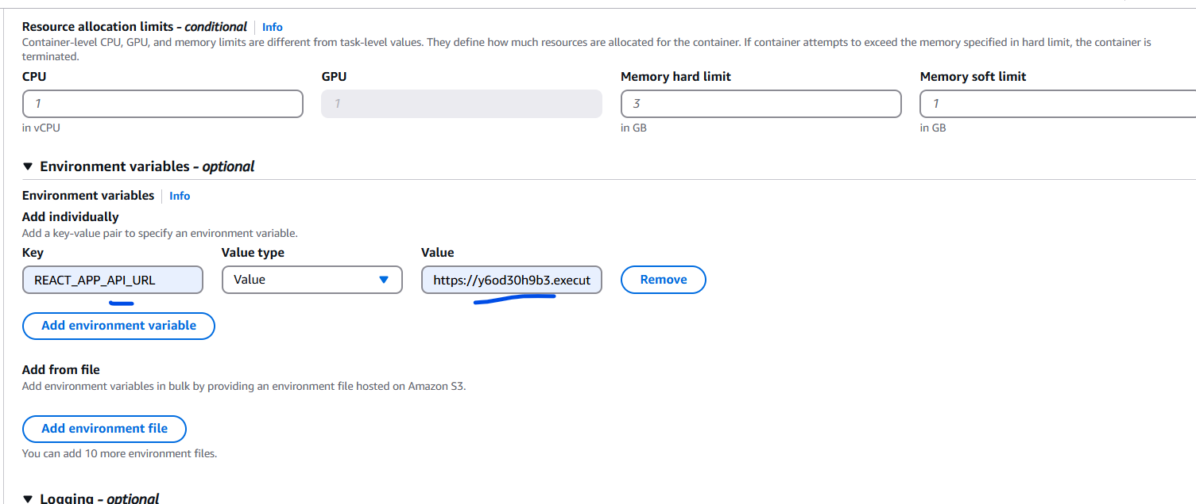
Similar to the docker compose file,
We have to pass the Env variables “REACT_APP_API_URL” with value of the API gateway which would then point to the backend public IP with port.
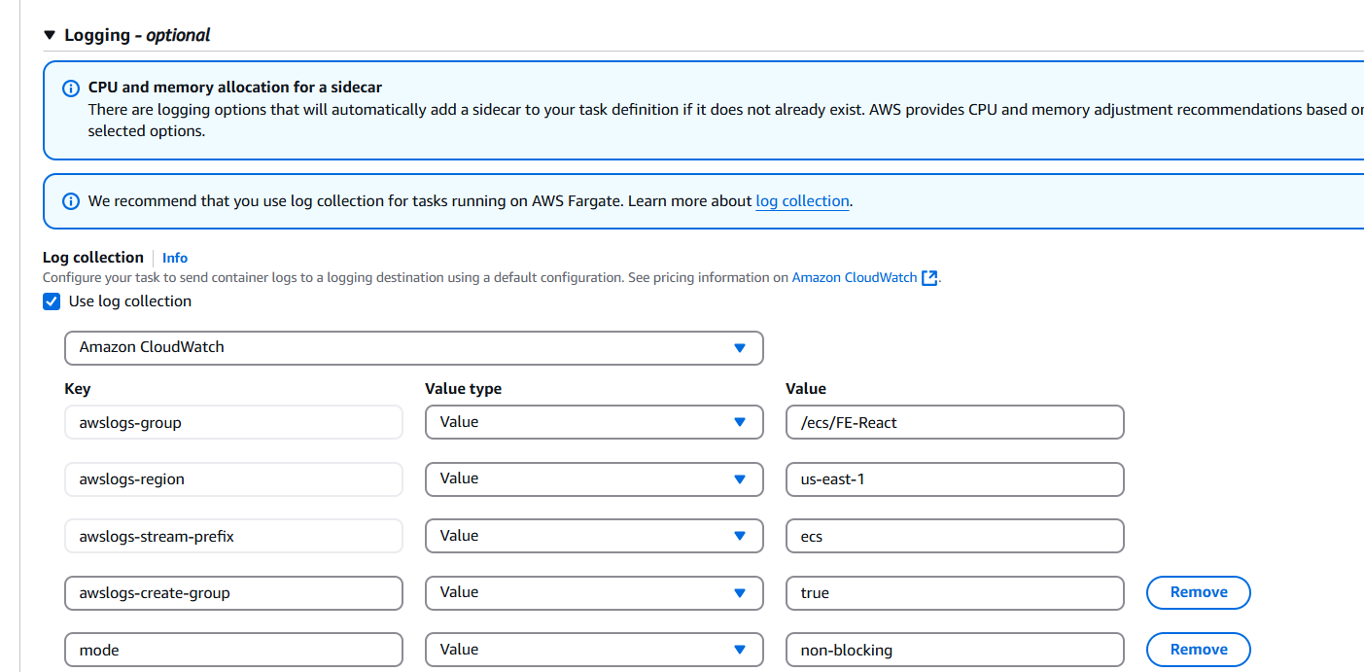

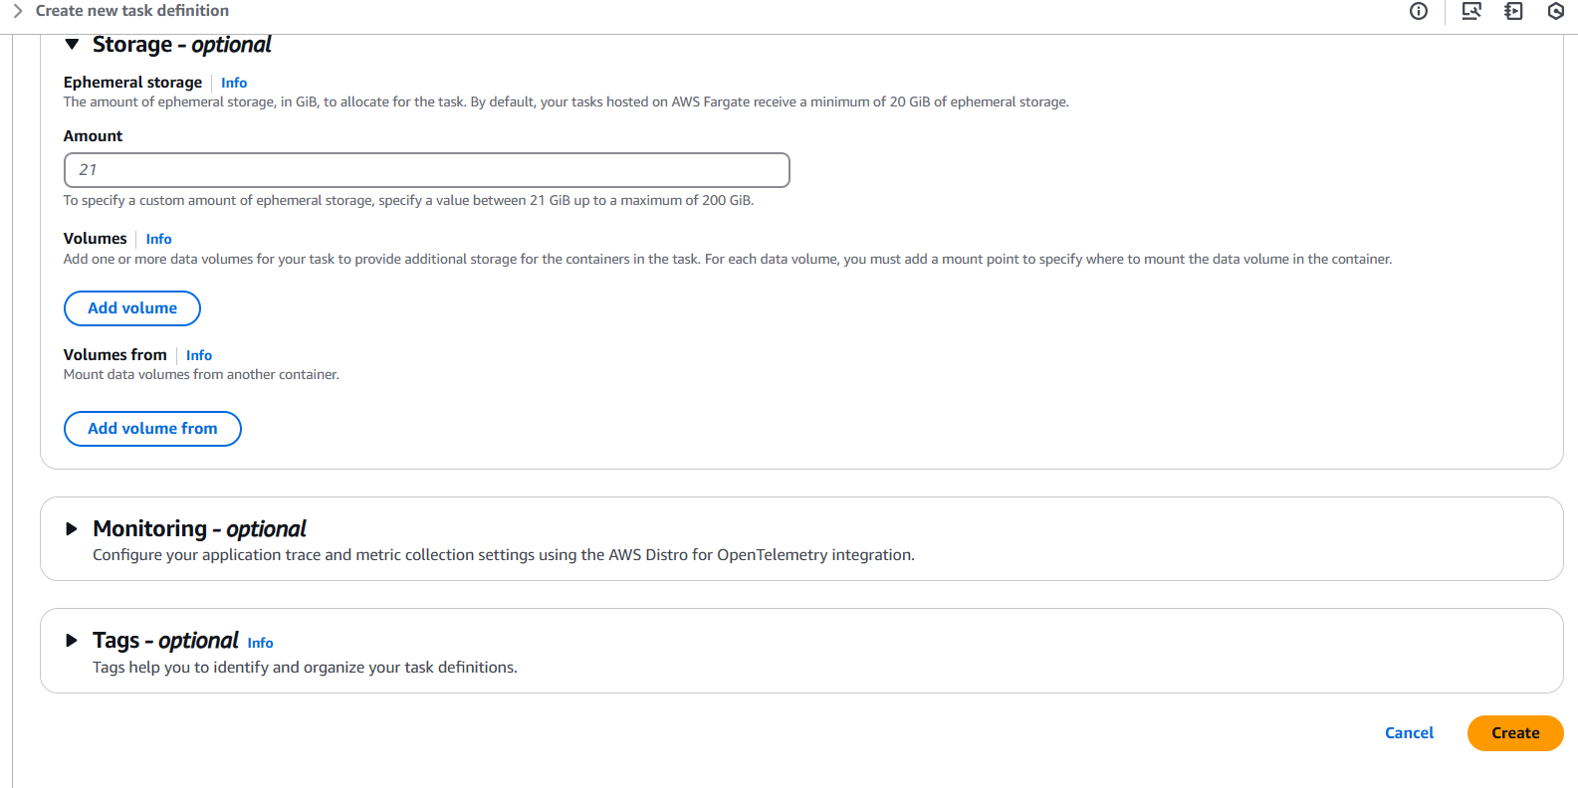

Step3: Create service for Frontend task
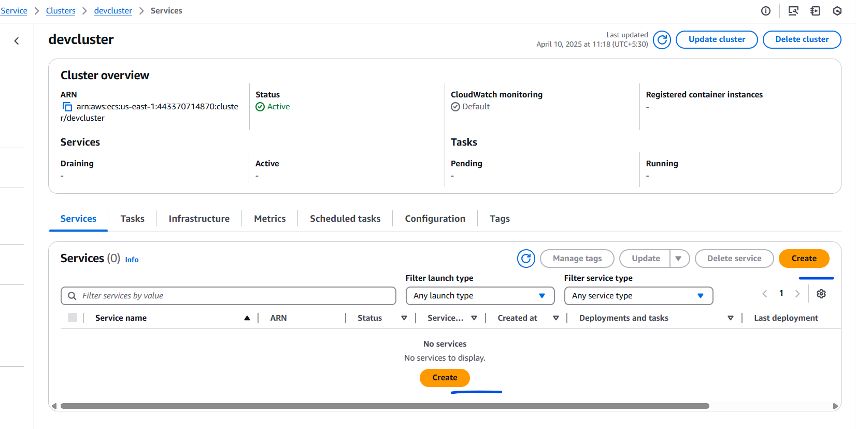
Click on “create” under the service option.
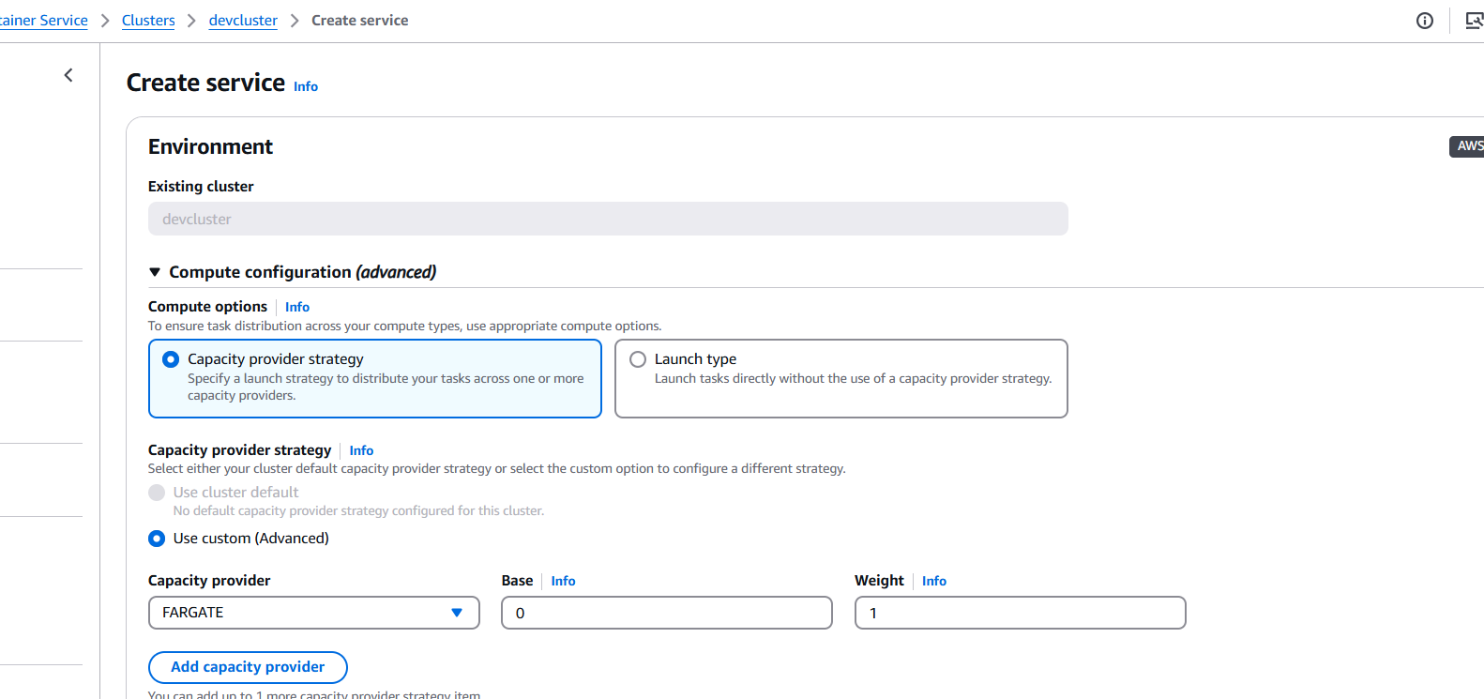
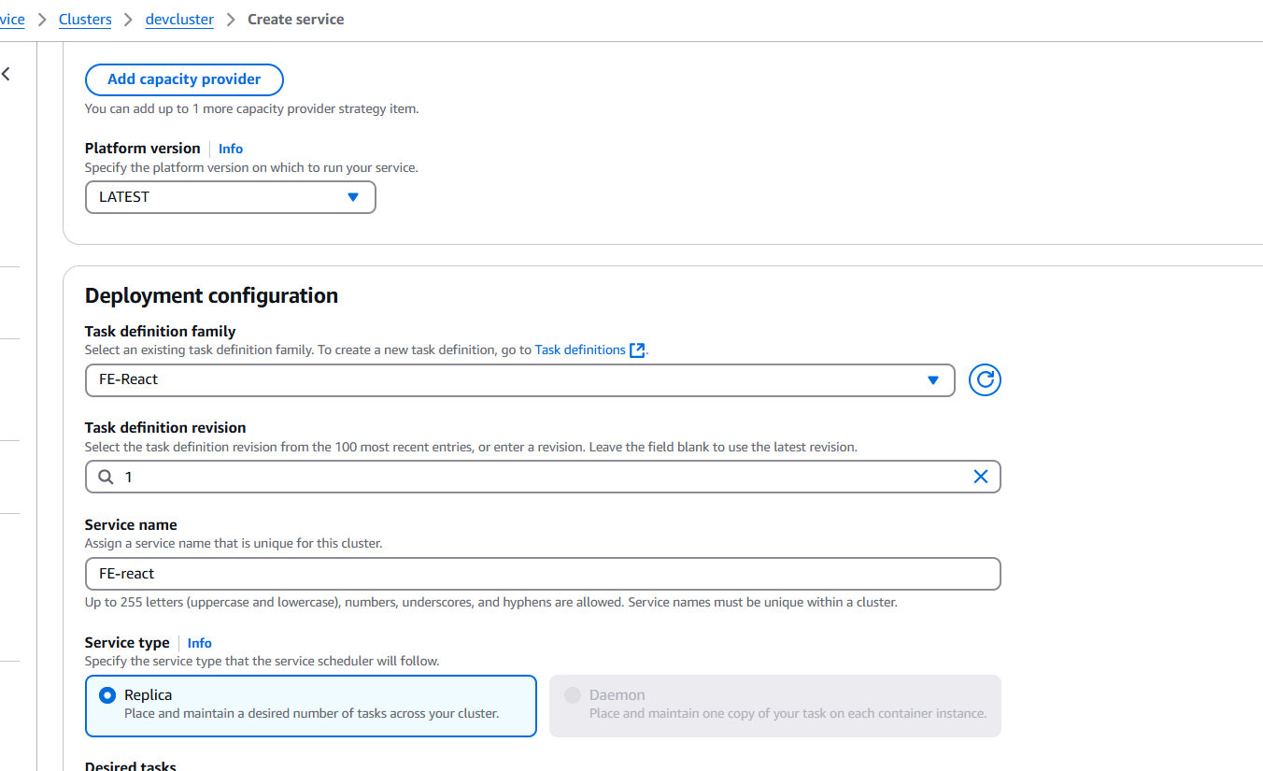
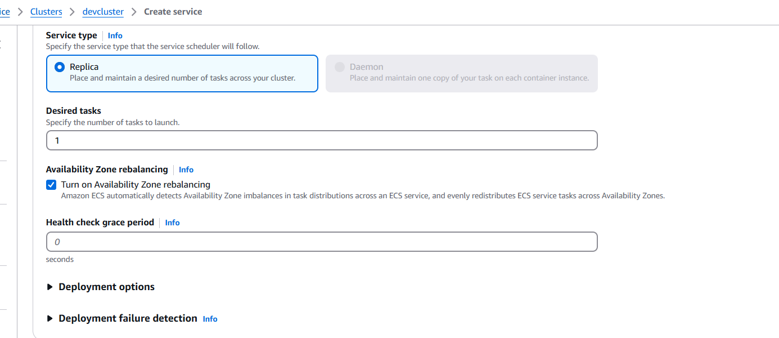
Configure the networking
Security group need to allow the port “80” for inbound.
Also make sure to enable public ip
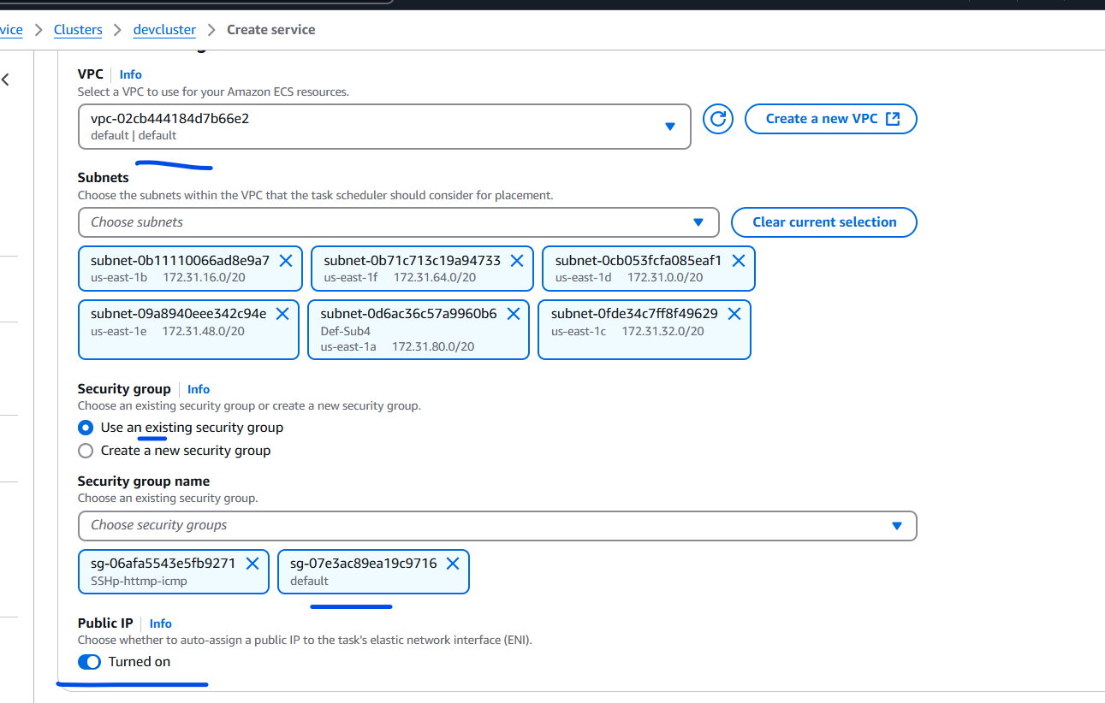
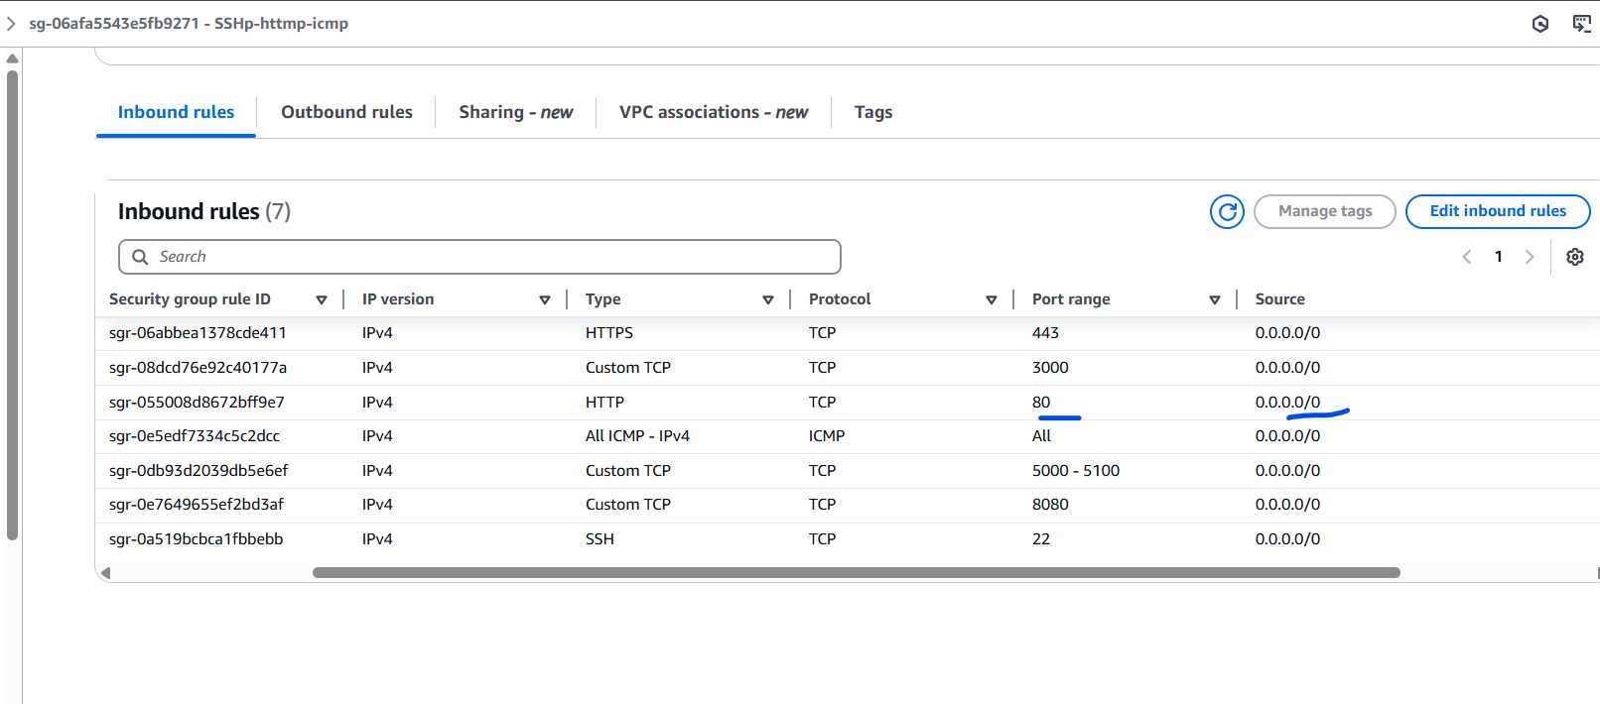
The SG has the port “80” opened for FE app to be accessible
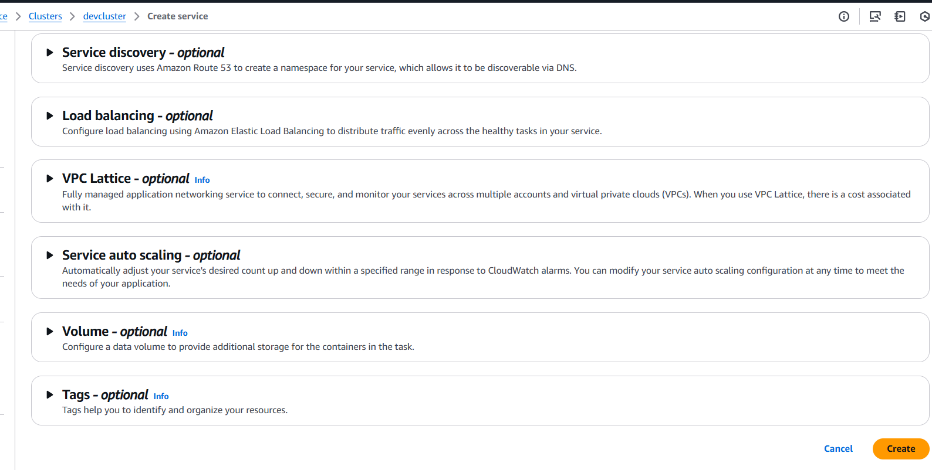

FE Service output:
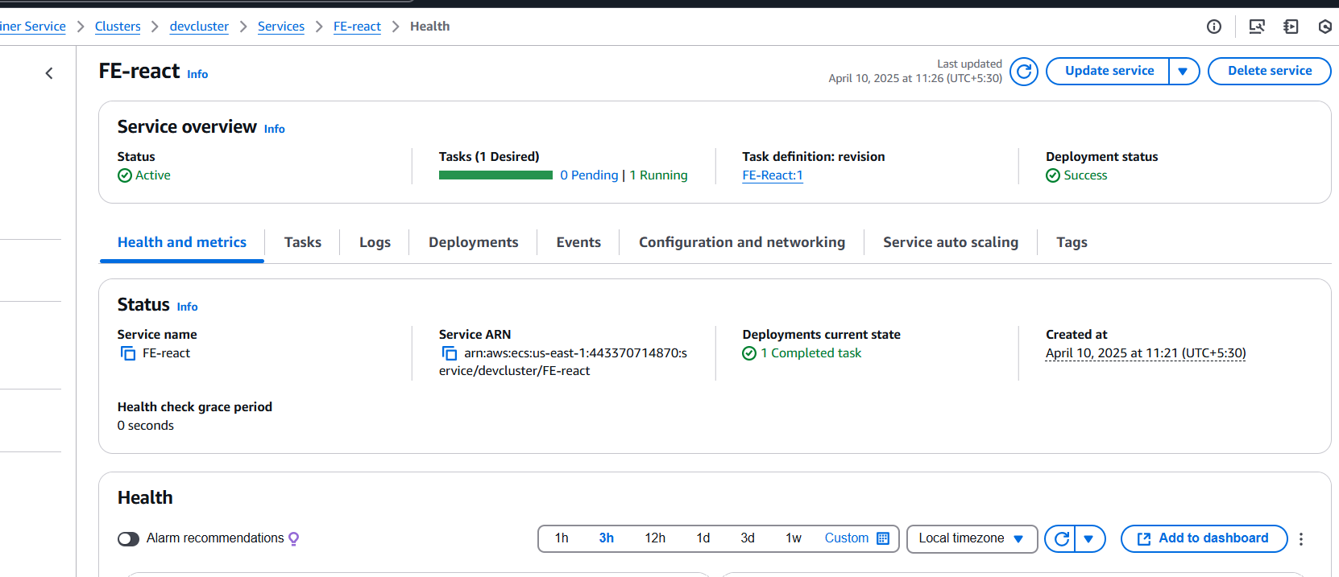
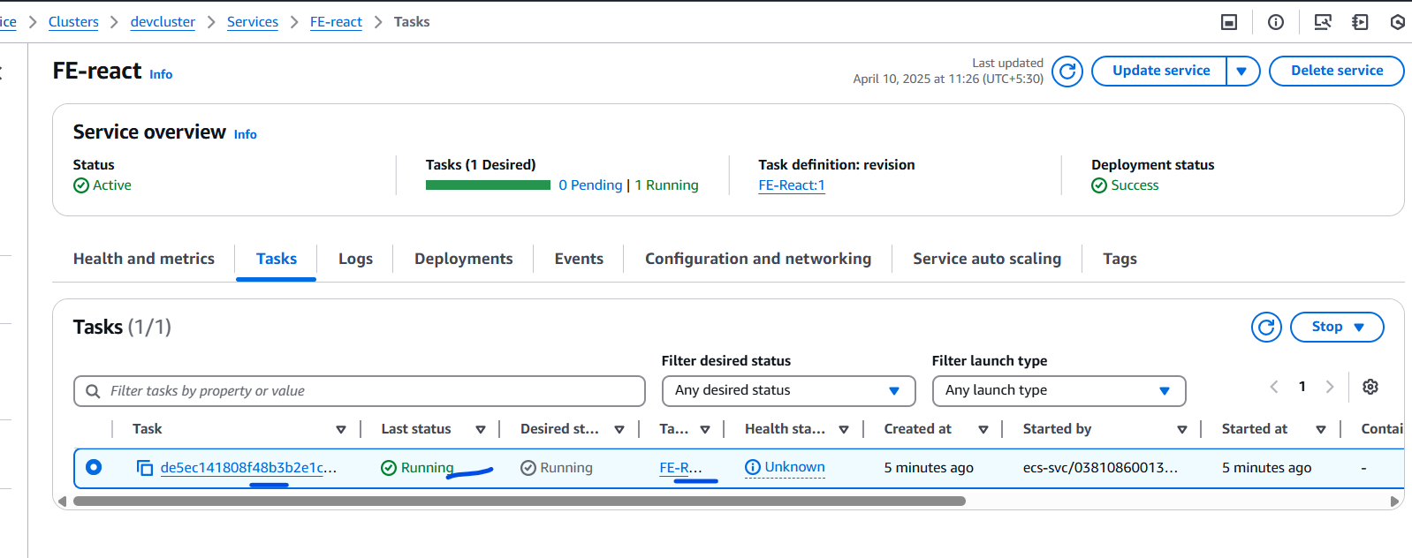
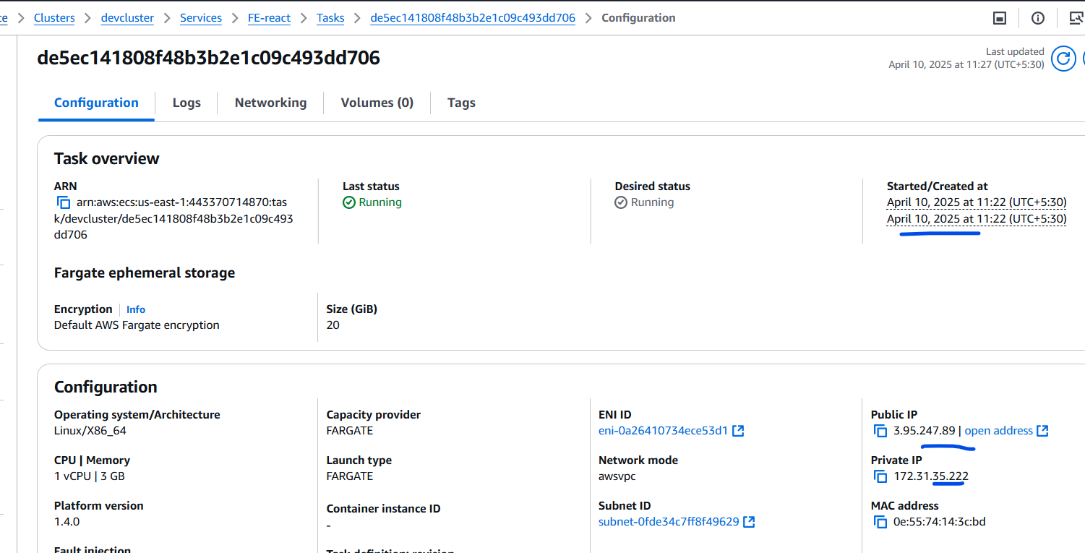
Take the public ip with port “80” the Frontend page should come up.
Note: if you have different port , make sure you have it properly configured in the task definition.
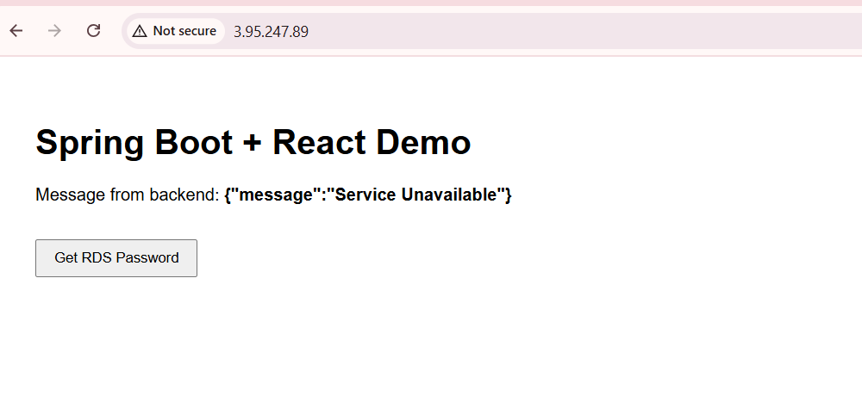
This is only the Frontend part.
NOW LETS CONFIGURE the backend containers.

Step4: Create Backend task definition
Here we have only 1 container for the backend.
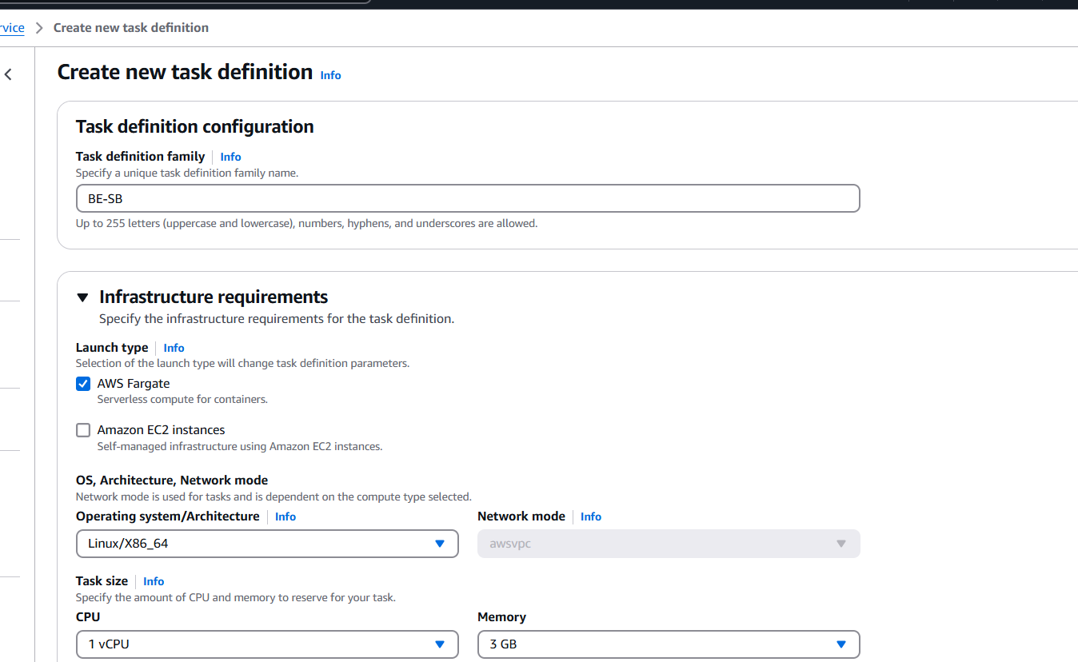
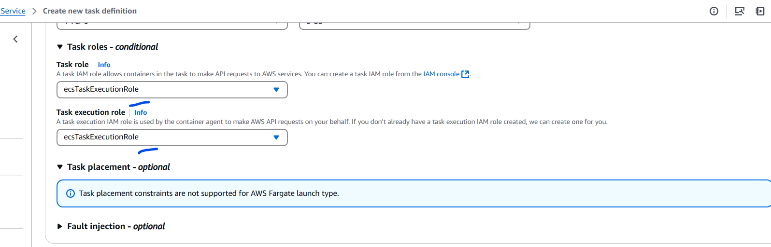

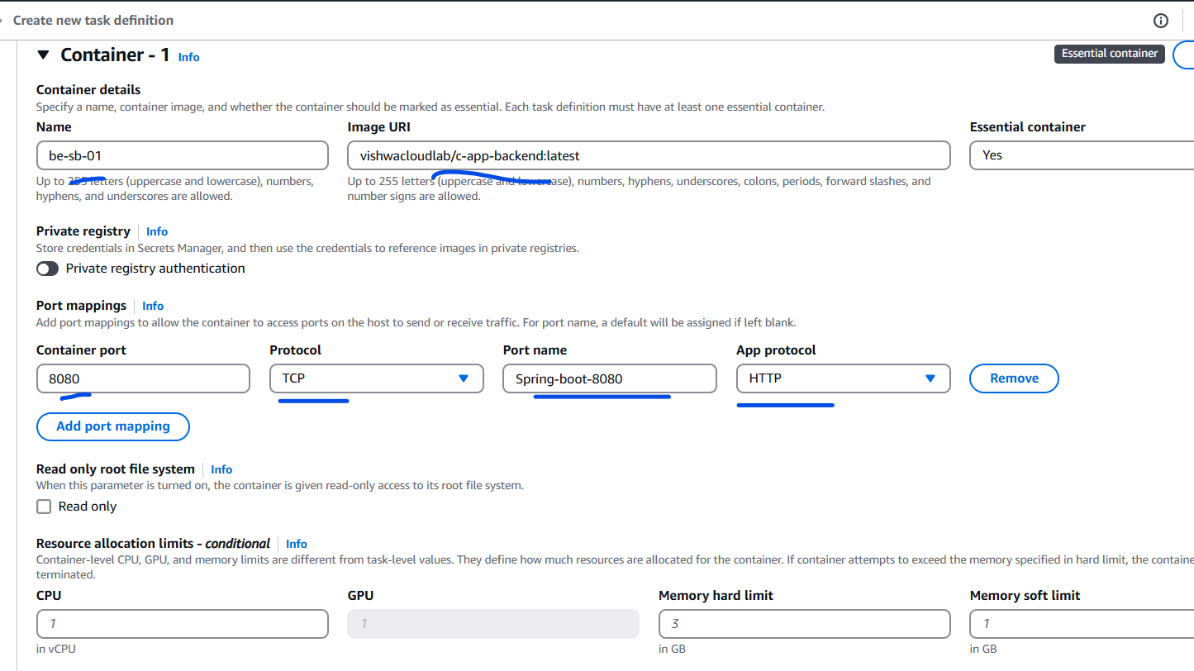
If you have more Backend microservice, create separate task definition ( Recommended method)
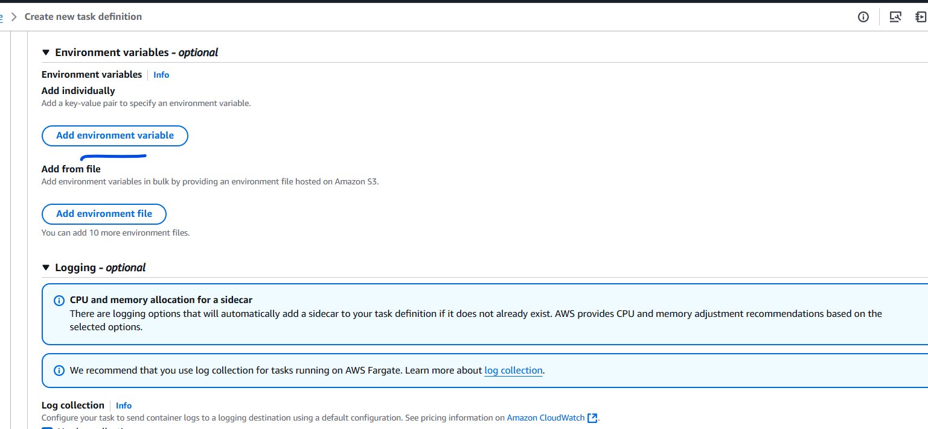
Current I Do not have any “Env” values to be passed for the backend
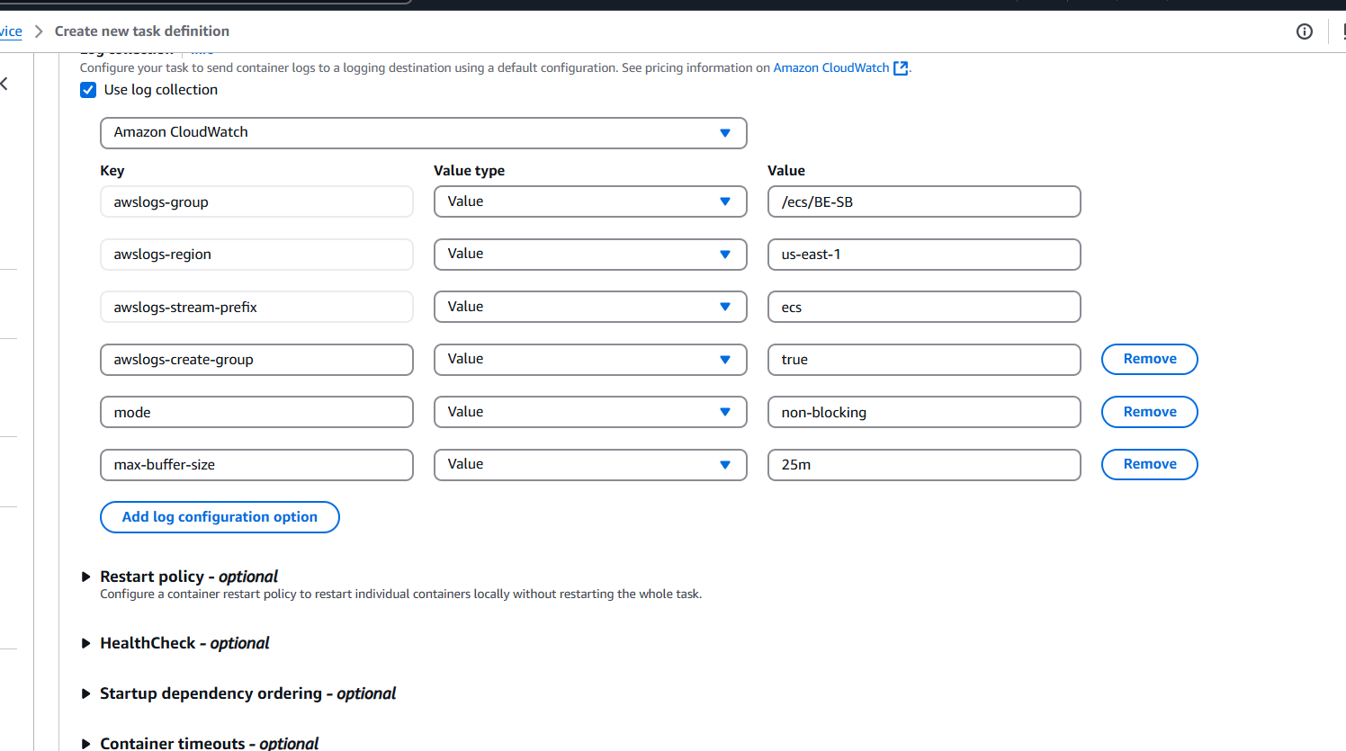
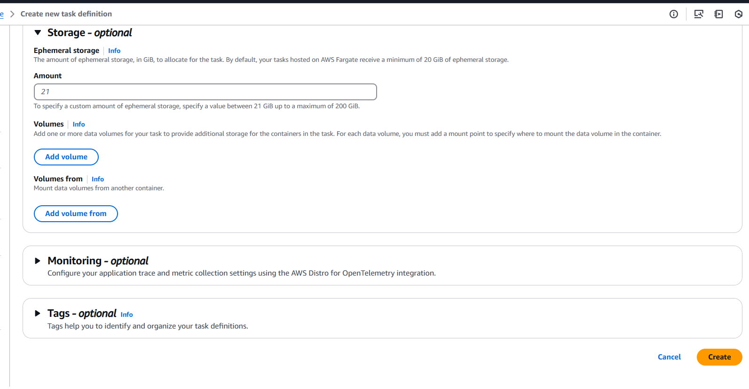
After creation:
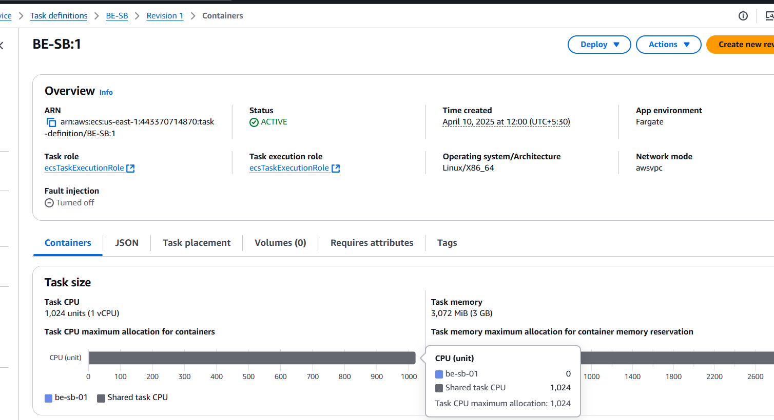
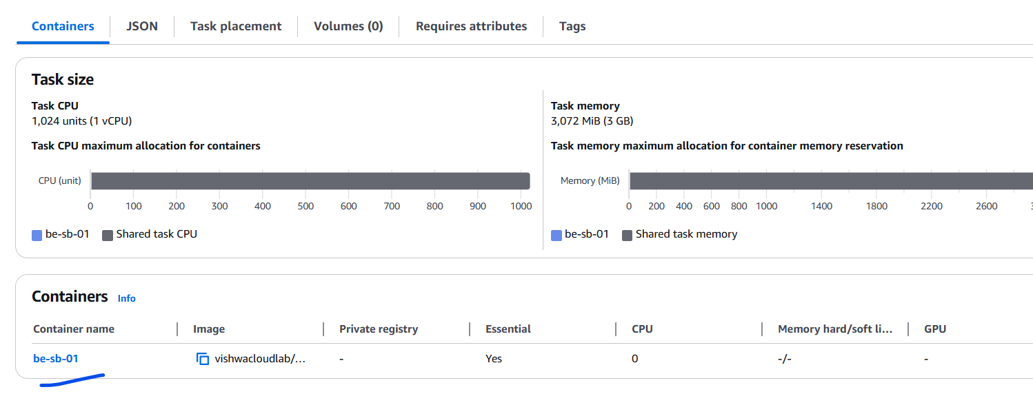

Step5: Create service for Backend task
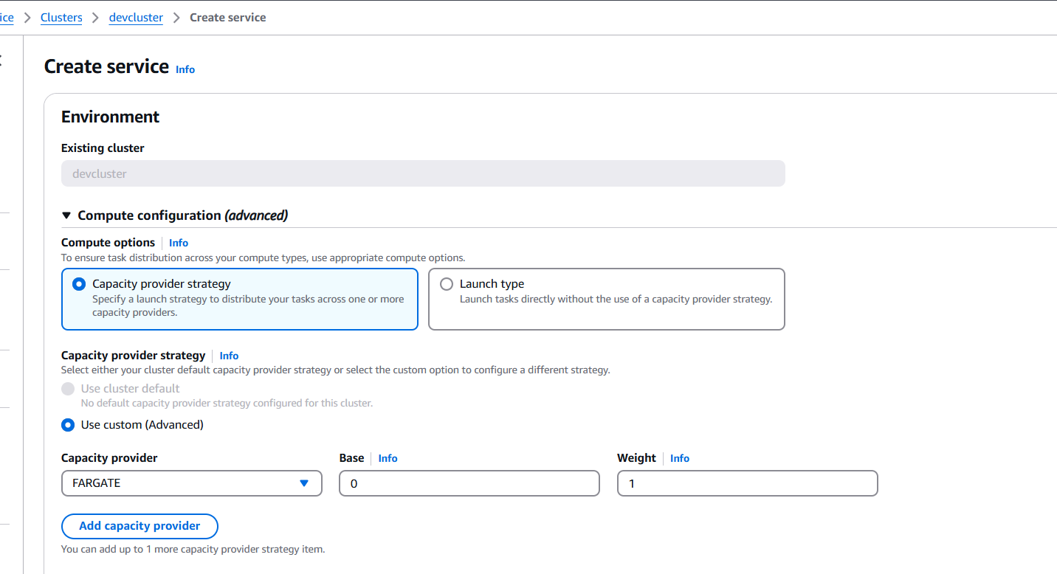
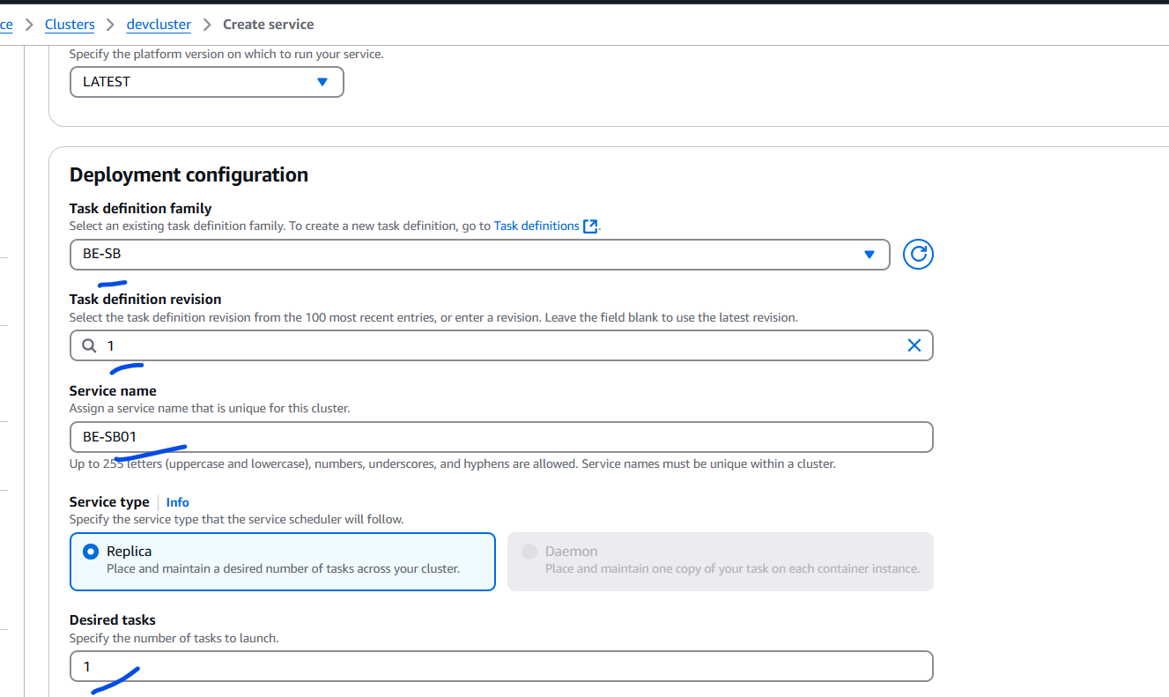
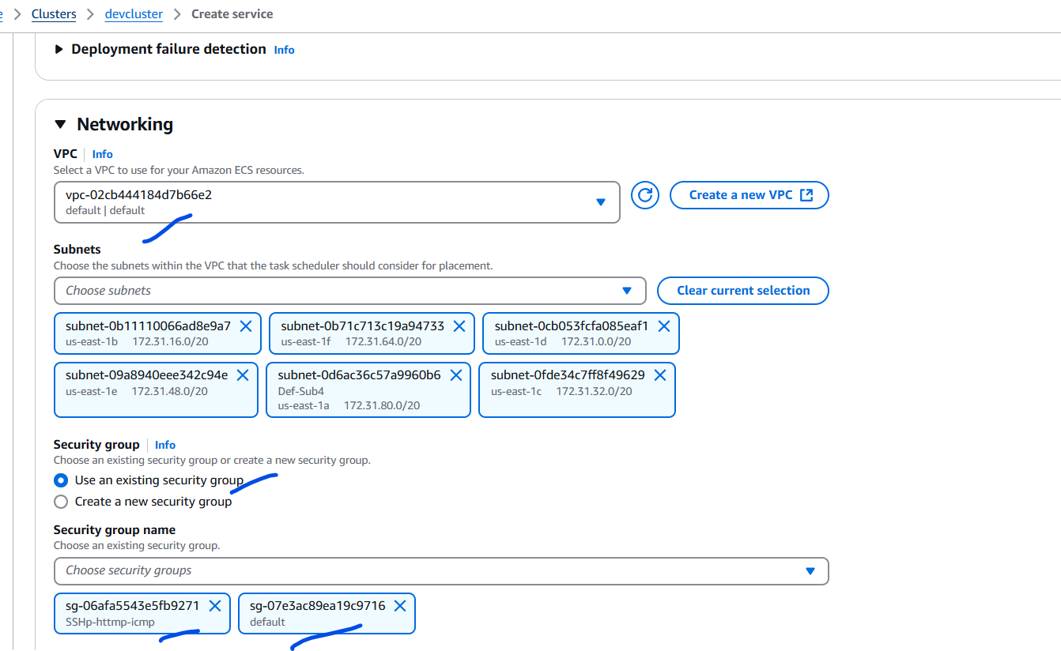
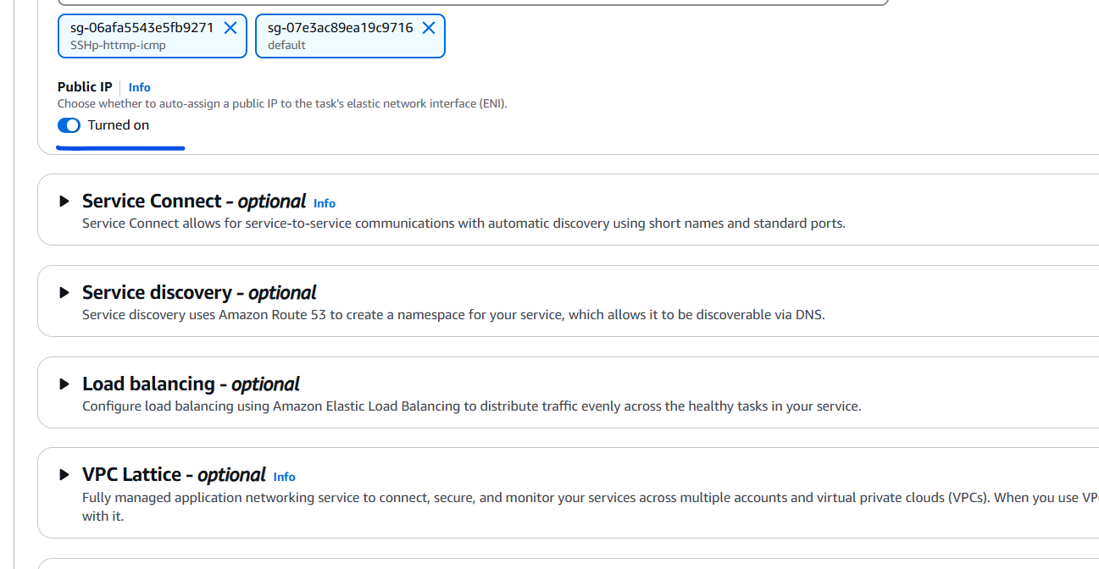
Make sure to Turn on the Public IP , so that it can be configured for the API gateway.
Output:
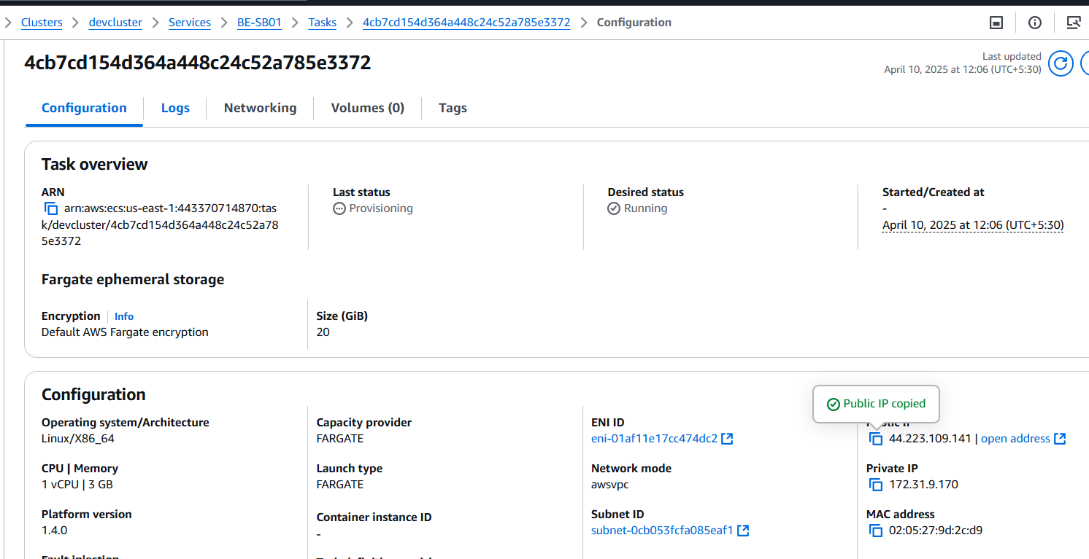
Take the Public IP, to configure on the existing API gateway.

Step6: API Gateway configuration
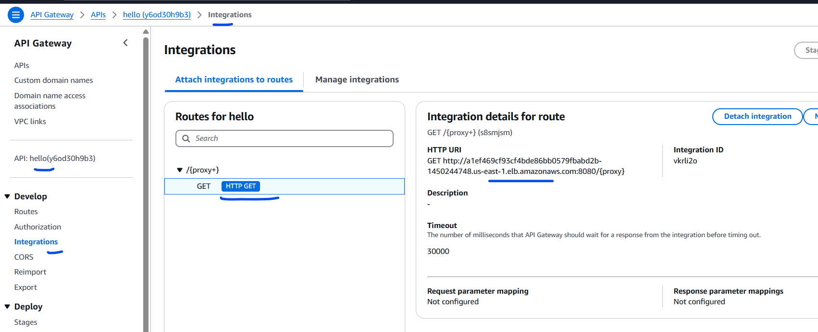
In the API Gateway change the integration URI
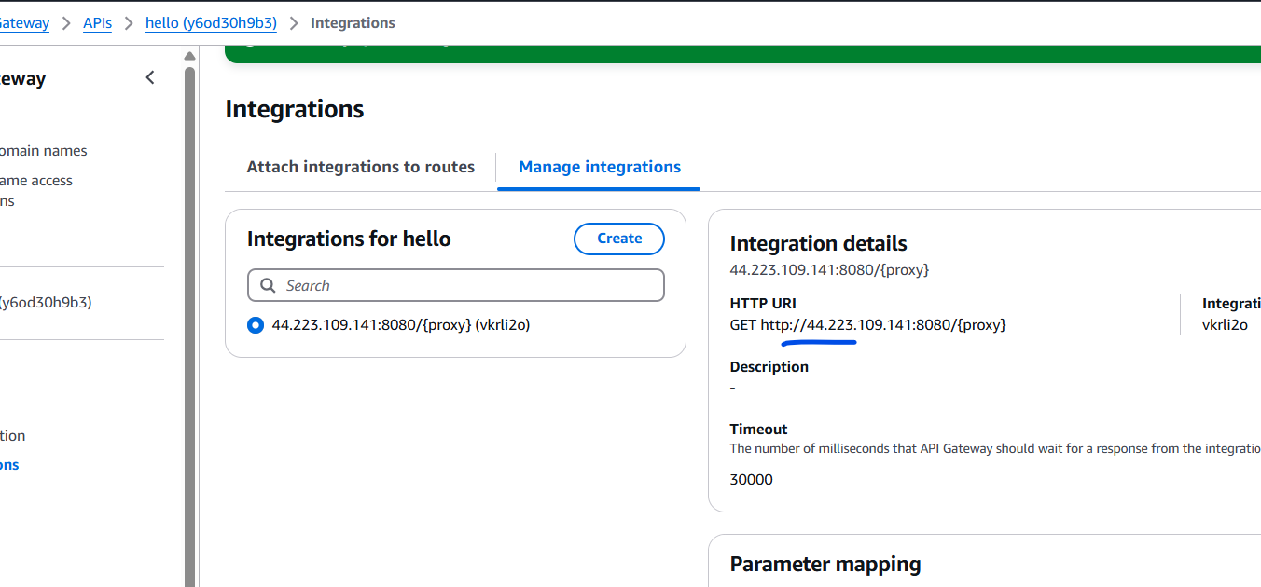
Public IP of the ECS service for the backend.
Testing output:
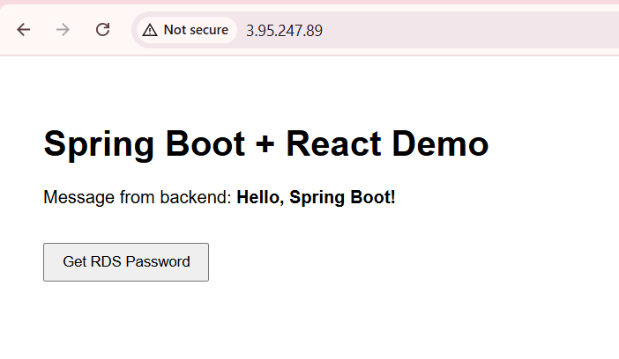
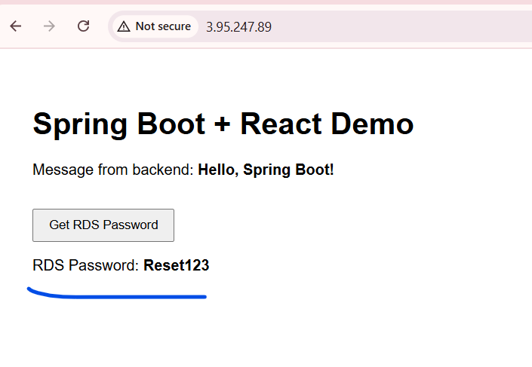
Clicking on the button will get the password, from Secrets Manager.
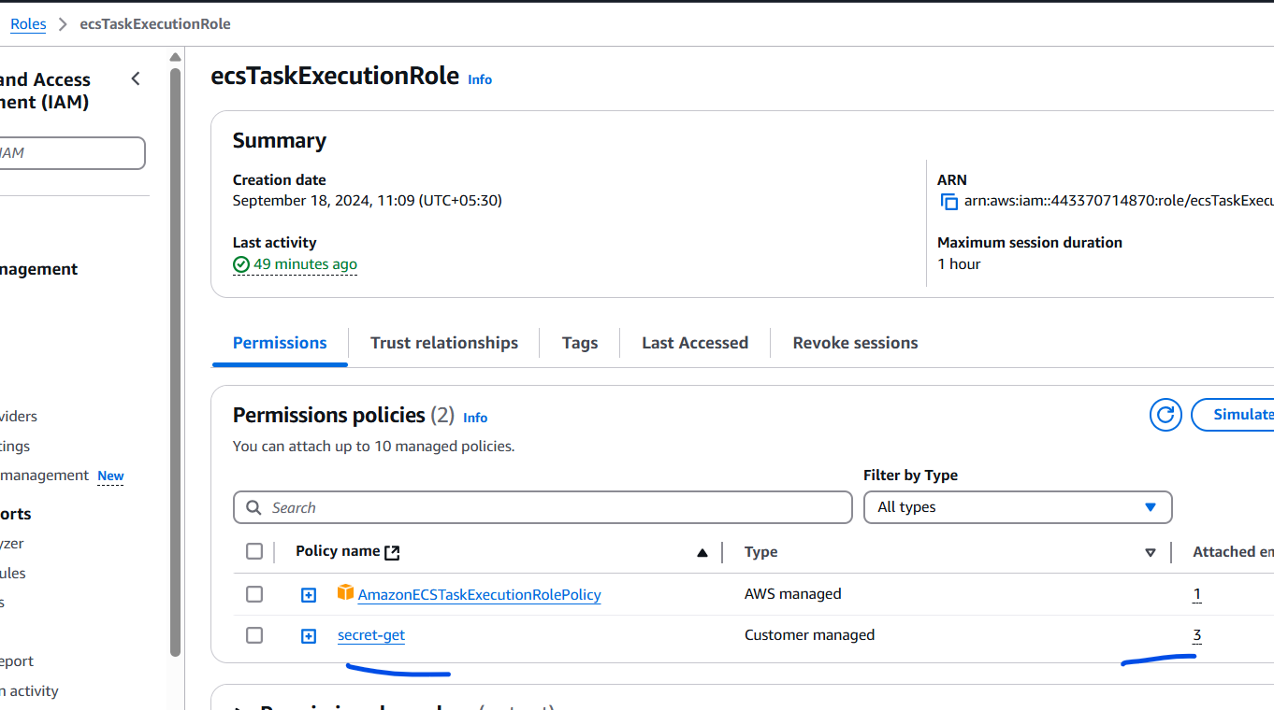
Make sure the policy to access the secrets are part of the Task Execution Role.
